**DETECTION OF HUMAN ACTIVITY USING MACHINE LEARNING TECHNIQUES**

**WITH SMARTPHONE SENSOR DATA ANALYSIS**

|  |  |
| --- | --- |
| 1st Dumpali Sharath Chandra Reddy | 2nd Kannanoor Spurgeon |
| *Master’s in computer science* | *Masters in Computer Science* |
| *University of New Haven* | *University of New Haven* |
| New Haven, CT | New Haven, CT |
| csharath301@protonmail.com | Skann14@unh.newhaven.edu |

***Abstract* - *This research study investigates the application of several machine learning algorithms for the detection of human activity based on smartphone sensor data. This study's dataset consists of 10299 x 563 data points obtained from 30 individuals participating in six distinct activities. The data was obtained using a tri-axial accelerometer and includes features such as acceleration magnitude, direction, frequency, and intensity that can be used to classify and recognize the performed activities. Linear support-vector-machine (Linear SVC), logistic regression, decision trees, gradient-boosted decision trees, support-vector-machine (SVM), random forests, k-nearest neighbors, and deep learning neural networks are the six techniques utilized in this study. Besides deep learning, grid search is also used to optimize the performance of these algorithms.***

***The study emphasizes the usefulness of machine learning approaches for analyzing and processing sensor data, as well as the significance of sensor data analysis for comprehending human actions. Data cleansing, feature selection, and model training and evaluation are all components of the study technique. Each algorithm's performance is evaluated using criteria such as precision, memory utilization, and F1 scores.***

***The findings of the study indicate that the proposed AI algorithm for human activity recognition performs comparably to other cutting-edge methodologies. The confusion matrices and data progressive system grids shed light on the categorization precision of various operations. The findings of this study may be valuable for creating intelligent systems that recognize human actions utilizing smartphone and other device sensor data. This work demonstrates the potential for machine learning algorithms to analyze and interpret sensor data in order to comprehend human activities.***

***Keywords*: *Logistic Regression, Linear Support Vector Machine (Linear SVC), Decision Trees, Gradient-Boosted Decision Trees, Support Vector Machine (SVM), Random Forests, K-Nearest Neighbors (KNN), Grid Search***

1. **INTRODUCTION**

**Detection of human activity is a fast-emerging field with applications in healthcare, transportation, and security, among others. This study attempts to evaluate the efficacy of several machine learning algorithms in detecting human actions using smartphone sensor data. In this paper,** linear support vector machine (Linear SVC), logistic regression, decision trees, gradient-boosted decision trees, support vector machine (SVM), random forests, k-nearest neighbors, and deep learning neural networks**are studied as techniques. Grid search is used to optimize the performance of these algorithms. We compare the outcomes of these algorithms using variables such as precision, recall, confusion matrix, classification report, sensitivity, and specificity.**

In the instance of algorithms that employ the grid search technique, we identify the estimate that produced the greatest score out of all the estimators generated by grid search. In addition, we determine the grid search parameters that gave the best results, the ideal number of cross-validation splits, and the score of the best estimator from the grid search, as determined by cross-validation, was calculated as the average. **Our research finishes with a discussion of the significance of our findings for future HAR research.**

1. **LITERATURE SURVEY**

Xing Su and Ping Ji's research paper discusses the benefits and drawbacks of human exercises and provides a framework for their classification. The paper categorizes human activities into two classes based on their use of different data and offers an analysis of existing exercises and requirements for recognizing precise data. Overall, the paper emphasizes the importance of engaging in physical activities and provides valuable insights into their classification and analysis. [1].

The paper study by Nicholas D. Lane's paper summarizes pre-handling factors, including perception, order, and follow-up, which are difficult to specify due to their numerous varieties. Understanding the progression of accomplishment is challenging and involves lighting, environmental change, shadow consciousness, countermeasures, and a conclusive result. Division procedures are the quickest and most accurate strategy to alter the display of previous advances, while informative methods are better for comprehending higher-level, more complex exercises. Factual strategies and analysis are ideal for addressing noise-related movements. [2].

Video surveillance plays a crucial role in various tasks such as identifying rare items, analyzing human movement, and recognizing evidence, sexual orientation, and aging. The first step is identifying moving objects, which can be achieved through reverse development, smooth development, and separating skills. Once an object is distinguished, individual identification can be executed through construction, design, and activity arrangement. This article provides an overview of the different methods used for recognizing individuals in observation videos. The last section discusses future exercises that can improve image processing, including the use of sporting activities and visual guides based on image components. [3].

1. **EXISTING SYSTEM**

This document aims to develop a comprehensive system for analyzing data gathered by portable sensors and accurately describing the weather. Numerous studies have been conducted on the use of Radio Signal Strength (RSS) analysis to determine the location of a lounge, but this method has limitations. RSS signal strength can vary by location, and visibility can be hindered by a variety of obstacles. Consequently, automated systems that rely on RSS measurements to predict the weather may not always be effective.

Therefore, in this article, we will investigate and propose various types of security based on data gathered from various devices integrated into a mobile device. We will use Convolutional Deep Neural Networks to analyze and predict the presence of specific objects at close ranges (radio I to IS) (CDNNs). CDNNs are frequently utilized in offices, hospitals, and public gatherings due to their ability to accurately recognize and categorize objects. Nonetheless, we also seek to enhance the quality of CDNNs so that the number of DNNs (Deep Neural Networks) can be reduced without sacrificing performance.

**A. Drawbacks**

* CDNN represents just 80.41% and 74.14% of accurate preparation and estimation data.
* Obviously, in a brief timeframe (like 1-1.5 radios), it is hard to isolate the item space.

1. **PROPOSED SYSTEM**

Human activity recognition is the classification of human activities based on sensor data using pattern recognition techniques. This method often entails a series of phases, including data gathering, data processing, and the building of classification models. Using machine learning techniques such as linear support vector machine (Linear SVC), logistic regression, decision trees, gradient-boosted decision trees, support vector machine (SVM), random forests, k-nearest neighbors, and deep learning neural networks are the prevalent method for identifying human behaviors on smartphones equipped with inertial sensors. Oftentimes, data cleaning and preparation, univariate analysis, bivariate analysis, multivariate analysis, variable identification are required for the effective classification of human activities. In addition to data analysis and comprehension, data visualization may also be utilized.

* Using a graphical user interface (GUI) application is one way to implement a machine learning strategy.
* This method combines different datasets from a variety of sources to create a generalized dataset. Several machine learning algorithms can then be applied to the dataset to detect trends and produce the most precise results.

**A. Advantages**

* The purpose of these reports is to examine the feasibility of implementing machine learning algorithms in real-world scenarios for the purpose of recognizing human activity.
* Additionally, the reports provide valuable perspectives on potential challenges, research questions, and demands that may need to be addressed in future studies.

1. **SYSTEM ARCHITECTURE**

**Filtering**

**Input from tri-axial accelerometer sensor**

**Segment data based on window size**

**Feature Extraction**

**(Max, Min, Mean, Peak)**

**Training data**

**Feature**

**Activity Recognition**

**(Classification)**

**Output**

**Fig. 1: System Architecture**

The human activity recognition (HAR) model uses machine learning algorithms to classify and predict human activities based on sensor data. The system architecture of a typical HAR model can be classified into three main components: data acquisition, feature extraction, and classification. Figure 1 depicts the system architecture of the HAR model using machine learning algorithms.

**A. Data Acquisition:** The first step of a HAR model's system architecture is the collection of sensor data. This information can originate from a variety of sources, including accelerometers, gyroscopes, and other wearable sensors. Typically, the data is gathered in real-time and stored in a database for subsequent processing.

**B. Feature Extraction:** After acquiring the data, the subsequent step is to extract meaningful features from the raw sensor data. This step is crucial because it determines the overall quality of the classification results. Various feature extraction techniques are available, such as time-domain, frequency-domain, and statistical methods. The extracted features are then utilized as classification inputs.

**C. Classification:** The last stage involves utilizing the obtained features to educate a machine learning model for categorization. Several algorithms, such as decision trees, support vector machines (SVMs), random forests, and deep neural networks, may be utilized for the training process. The model obtained after training is then utilized to classify fresh sensor data instances and estimate the associated human activity.

The overall system architecture of a HAR model employing machine learning algorithms consists of the acquisition of sensor data, the extraction of meaningful features, and the training of a machine learning model for classification. This architecture is widely employed in research to categorize and predict human activities, yielding valuable insights into human behavior and movement patterns.

**D. List of Modules**

* Data Acquisition and overview of the dataset
* Data Preprocessing Technique
* Data Analysis and Visualization
* Evaluating algorithms by comparing their best accuracy result with the predicted outcome.
* Model Deployment using Flask

1. **MODULE DESCRIPTION**
2. **DATA ACQUISITION AND OVERVIEW**

The data was obtained using a tri-axial accelerometer and includes features such as acceleration magnitude, direction, frequency, and intensity that can be used to classify and recognize the performed activities. 30 participants (referred to as subjects) provide accelerometer and gyroscope readings while undertaking the following 6 Activities: Walking, Walking-Upstairs, Walking-Downstairs, Sitting, Standing, and Laying.

Readings are separated into a 2.56-second frame with 50% overlap. Accelerometer results are classified as gravity acceleration or body acceleration, with x, y, and z components. Gyroscope readings are angular velocity measurements with x, y, and z components. BodyAcceleration measurements provide jerk signals. To obtain frequency data, Fourier Transforms are applied to the above time readings. For each window, mean, max, mad, sma, arcoefficient, engerybands, entropy, and so on are determined based on all of the base signal values. We get a feature vector with 561 features, which are included in the dataset.

1. **DATA PRE-PROCESSING**

Data pre-processing involves the process of cleaning, transforming, and organizing raw data before it's used for analysis or modeling. This is an essential step in the exploration process as it ensures the data is accurate, harmonious, and complete. Data pre-processing includes tasks similar to data cleaning, metamorphosis, integration, and reduction. Data drawing involves removing or correcting any crimes (errors) or inconsistencies in the data. Data metamorphosis involves converting the data into a format that can be fluently anatomized. Data integration involves combining multiple data sources into a single dataset. Data reduction involves correlating and removing gratuitous data.

As shown in Figure 2, the implementation of data pre-processing is a critical step in any research as it ensures that the data is clean, accurate, and suitable for the research objectives. Without proper data pre-processing, the research results may be unreliable or invalid.

**Module Diagram**



**Fig. 2: Module Diagram for Data Pre-Processing**

1. **DATA VALIDATION/CLEANING/PREPARING**

The library package was initially imported in order to examine and potentially modify the media type and format. The objective is to comprehend and reflect on the presented values. The accuracy of the model is determined by the information stored during its creation and used to display and manage its design. While examining the model, this information can also be used to validate and test the setup data. It is possible to modify the data by renaming it or dividing it into smaller segments for additional analysis. The steps and technological processes of various storage systems may vary. The primary objective of data cleansing is to identify and eliminate errors and inconsistencies, detection and removal of outliers, normalization and scaling of data to account for variations, and selecting the most relevant features for analysis so as to enhance the data's value for analysis and guidance.

1. **EXPLORATION DATA ANALYSIS OF VISUALIZATION**

In science and AI, demonstrating outcomes is crucial. Mathematical and statistical methods are necessary for effective data analysis. Validating data frequently requires graphical representations, such as charts and tables. Access to testing data and multiple techniques is essential for statistical analysis and artificial intelligence. This paper will discuss techniques for gaining a better understanding of data, including alternative plot designs and methods for data distribution such as histograms and box plots.

False positives and false negatives are essential to understanding the accuracy and dependability of a model or algorithm within the fields of machine learning and data analysis. True positives and negatives are also essential metrics. Understanding the difference between these four metrics is crucial for evaluating the performance and precision of a model or algorithm. Figure 3 depicts the data visualization implementation.

**Module Diagram**

Data Processing

Data Sources

Data Visualization

**Fig. 3: Module Diagram for Data Visualization**

1. **EVALUATING ALGORITHMS BY COMPARING THEIR BEST ACCURACY RESULT WITH THE PREDICTION**

Analyzing and testing different ML algorithms in Python with scikit-learn is crucial. This technique can help solve AI issues and generate insights. Each model has distinct capabilities. Cross-validation provides a recursive description of how any model might be correct in unseen data. Selecting the greatest models from your template by using templates is also important. New data must be understood using different methods. Choose a model. To verify your machine is learning the algorithm effectively, you may wish to employ many methods. Imaging methods can illustrate the genuine differences between model distribution components.

The following section will analyze AI algorithms using Scikit-Learn in Python. Continuously testing algorithms on the same data guarantees fairness. AI will improve accuracy.

The K-fold cross-validation method verifies the consistency of every computation. To compare computations, construct a Scikit-Learn AI model. This library offers structured programming, direct modeling with an inverse approach, K-Fold validation, and grid search using tree models. Reduce and refine the model via training, and compare the results to actual data.

**a. Prediction result by accuracy:**

Accuracy is vital in predictive modeling to assess performance. Probabilities, binary classifications, or other forms express predictions. In relapse prediction, the True Positive Rate identifies actual positive cases correctly, and the False Positive Rate misidentifies actual negative cases.

True-Positive Rate {TPR}= Sensitivity = TP / [FN + TP]

False-Positive Rate {FPR} = FP / [TN + FP]

**Truth:** To evaluate the model's ability to predict positive and negative cases, you can analyze the ratio of predicted values to the overall sample size.

**b. Accuracy calculation:**

Accuracy/Valid = [TP + TN] / [FP + FN + TP + TN]

The accuracy of a model is determined by its capacity to predict both positive and negative outcomes. If the evaluation is honest, you can conclude that our model is superior. Truthfulness is important, as it allows us to fully understand the value of false positives and false negatives.

**c. Precision:** An illustration of a decent prediction. (When the model predicts special (positive) cases, how suitable is it?)

Precision = positive predictive value = TP / [FP + TP]

Consider the scenario of individuals who are well-prepared, moderately-prepared, and poorly-prepared. There is a question about how many of these individuals have reported surviving. The low number of false positives accounts for the high accuracy. We achieved an excellent level of precision of 0.9682.

**d. Recall:** The proportion of accurately predicted positive cases. (The model identifies all genuine instances accurately.)

Remembering = TP / [TP + FN]

**e. Sensitivity and Specificity**: Sensitivity is a measurement of consistency and accurate identification of true positive instances across all classes, while specificity is the capacity to accurately distinguish true negative cases.

**f. F1 Score:** The F1 Score is a measure of the equilibrium between precision and recall and is more informative than accuracy alone. If you have a specific task in mind, you should prioritize F1 over simplicity, despite the importance of clarity. F1 may be used if the cost of true positives and false positives is equal. Nonetheless, if the cost of these outcomes varies, it is wise to take into account both recall and precision.

Formula general: F1 Score = 2TP / (FP + FN + 2TP)

F1 Score = 2 * (Precision * Recall)/ (Recall + Precision)

1. **ALGORITHMS AND TECHNIQUES**

Classification is a widely used supervised learning technique in machine learning and statistics. It involves teaching a computer program to recognize patterns in input data and use this knowledge to categorize new data. The data set used for classification can be binary or multi-class, depending on the number of categories involved. Instances of classification tasks consist of identifying speech patterns, recognizing biometric features, analyzing handwriting, and categorizing documents. The supervised learning algorithms used for classification rely on labeled data to learn patterns and make predictions about new, unlabeled data. Figure 4 shows an example of how an algorithm can be trained on data to create a model for classification purposes.

**Module Diagram**

Implementing Algorithm

Split Train/Test Data

Read Data

Import Packages

**Fig. 4: Module Diagram for Implementing Algorithm**

**A. Logistic Regression:** Logistic regression is a prevalent classification approach used to assess the likelihood of a binary outcome. Using a sigmoid function, the linear approach's output is converted into a probability score.

**B. Linear SVC:** A form of Support Vector Machine (SVM) used for binary classification. It locates the hyperplane that separates the two classes in the input space by the greatest margin possible.

**C. SVM:** SVM is a potent classification method that identifies the optimal hyperplane that divides classes by the greatest margin. It is a non-linear algorithm applicable to both linearly and non-linearly distinct data.

**D. Decision Tree:** A common decision-making technique that employs a tree-like representation of alternatives and their anticipated outcomes. According to the values of the input qualities, the input space is subdivided into increasingly smaller sections.

**E. Random Forest:** An established technique in ensemble learning involves amalgamating various decision trees in order to enhance the predictive accuracy/validity of a model. This involves the creation of multiple decision trees, the results of which are combined to generate a final prediction.

**F. Gradient Boosting Decision Tree:** An additional strategy for ensemble learning that combines many decision trees. It operates by progressively constructing decision trees that correct the flaws of the trees that came before them.

**G. KNN:** A classification technique that identifies the k-nearest neighbors of a new input and uses the class that occurs most frequently among those neighbors as the forecast.

**H. Logistic Regression with Grid Search:** Using grid search to optimize the model's hyperparameters, including the regularization parameter, in logistic regression with grid search.

**I. Linear SVC with Grid Search:** A variation of linear SVC that optimizes the model's hyperparameters, such as the C parameter, via grid search.

**J. SVM with Grid Search:** A variant of SVM that utilizes grid search to optimize the model's hyperparameters, including the kernel type and regularization parameter.

**K. Decision Tree with Grid Search:** A type of decision tree that uses grid search to improve the model's hyperparameters, including the maximum depth and lowest number of samples required to divide a node

**L. Random Forest with Grid Search:** A form of random forest in which grid search is used to maximize the model's hyperparameters, such as the maximum depth of each tree and the number of trees.

**M. Gradient Boosting Decision Tree with Grid Search:** A variant of gradient boosting decision trees that uses grid search to optimize the model's hyperparameters, such as the learning rate and maximum depth of each tree.

**N. KNN with Grid Search:** A variation of KNN that uses grid search to improve the model's hyperparameters, including the number of neighbors and distance measure.

**O. Deep Learning:** A neural network model capable of learning sophisticated representations of incoming data. To extract features from input data, numerous layers of nonlinear transformations are utilized.

**VIII. MODEL DEPLOYMENT**

For the Linear SVC Grid Search model to be implemented on a website, a web application using the Flask framework and HTML that allows users to input data and receive predictions is required. Before it can be used, the Linear SVC Grid Search model must be trained and saved, and the web application must load it for every prediction.

Additionally, it is also possible to deploy the model on a mobile application. To create a mobile application, you can use a mobile app development framework such as React Native or Flutter.

In conclusion, deploying the Linear SVC Grid Search model to a website or mobile application entails creating a user interface for data input, utilizing the model to make a prediction, and displaying the predicted output to the user. Using the most accurate algorithm, this web application predicts Human Activity Recognition (HAR) in real time. Figure 5 demonstrates the deployment of the model.

**Module Diagram**



**Fig. 5: Module Diagram for Deployment of Model**

**IX. EXPERIMENTAL RESULTS AND OBSERVATIONS**

1. **Data Pre-Processing**

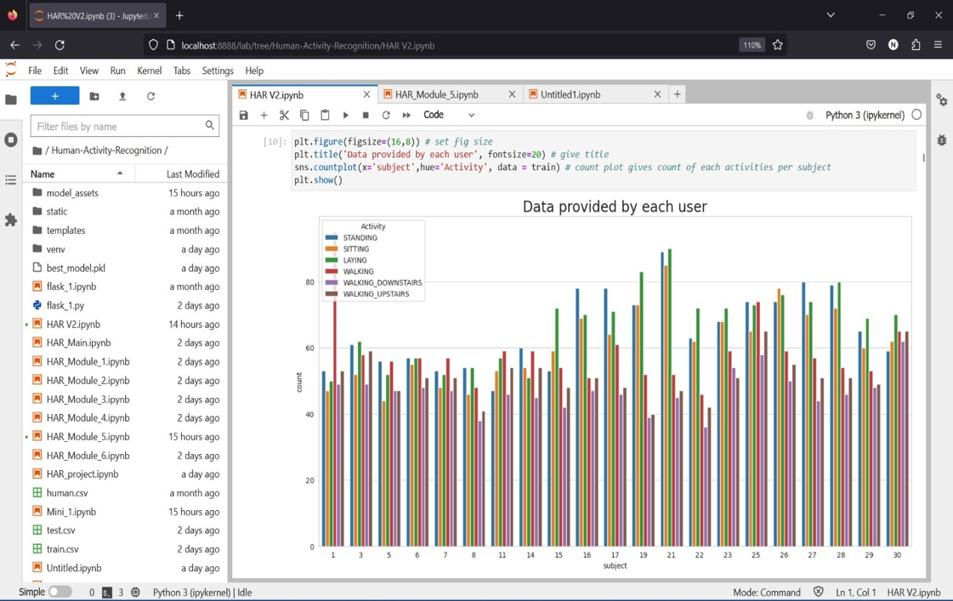

**Fig. 6: Data provided by each user or subject**

**Observations (Fig. 6):**

* Each activity is almost the same for all volunteers.

1. **Exploratory Data Analysis**

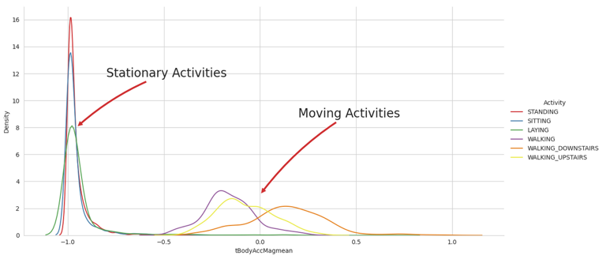

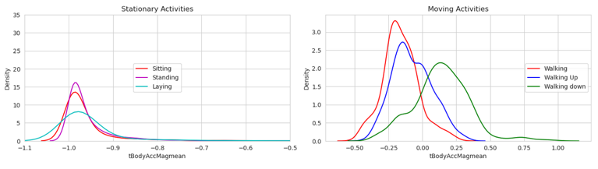

**Fig. 7: Histogram of tBodyAccMagMean vs. Density**

**Observations (Fig. 7):**

* The plot above shows that for dynamic activities, the feature value 'tBodyAccMagmean' is greater than -0.5, allowing for easy differentiation between stationary and moving activities.
* The graph/plot shows that the mean of body acceleration magnitude varies across different activities. The first subplot reveals a clear separation between the mean values of stationary activities, whereas the second subplot shows a relatively similar distribution of mean values for moving activities. Overall, the graph gives an intuitive visualization of how the body acceleration magnitude mean differs across different activities.

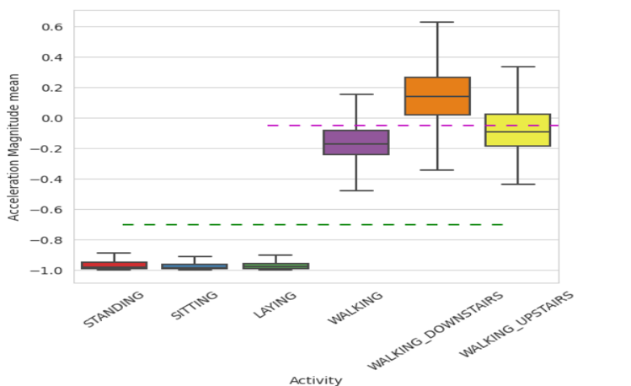

**Fig. 8: Acceleration Magnitude Mean vs Activity**

**Observations (Fig. 8):**

* When tAccMean falls below -0.8, the Activities can only be classified as Standing, Sitting, or Laying.
* If tAccMean exceeds -0.6, the Activities can only be classified as Walking, WalkingDownstairs, or WalkingUpstairs.
* If tAccMean is above 0.0, the Activity can only be classified as WalkingDownstairs.
* Approximately 75% of the Activity labels can be classified with some margin of error.

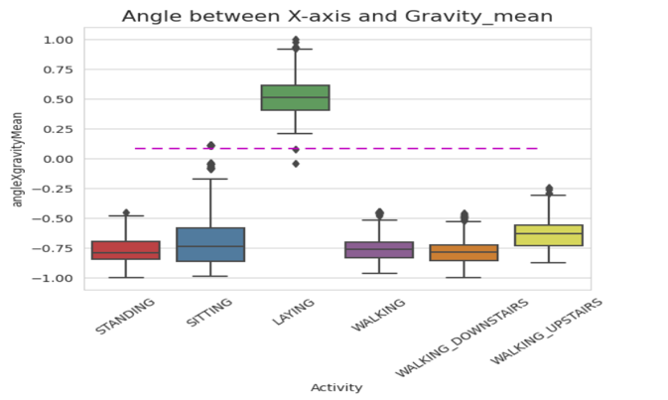

**Fig. 9: AngleX, Gravity Mean vs Activity**

**Observations (Fig. 9):**

* If gravityMean for angleX > 0, then Activity is Laying.
* It is possible to classify all data points associated with the Laying activity using a single conditional statement with if-else.

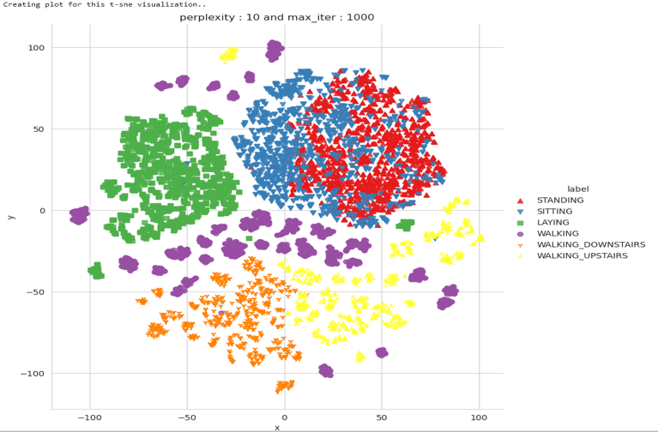

**Fig. 10: T-SNE Visualization of activities**

**Observations (Fig. 10):**

* From the above plot, it is clear that all activities can be distinguished except for standing and sitting, as these two activities overlap with each other.
* After building a model, maybe it will be difficult for the model to distinguish between these 2 classes.

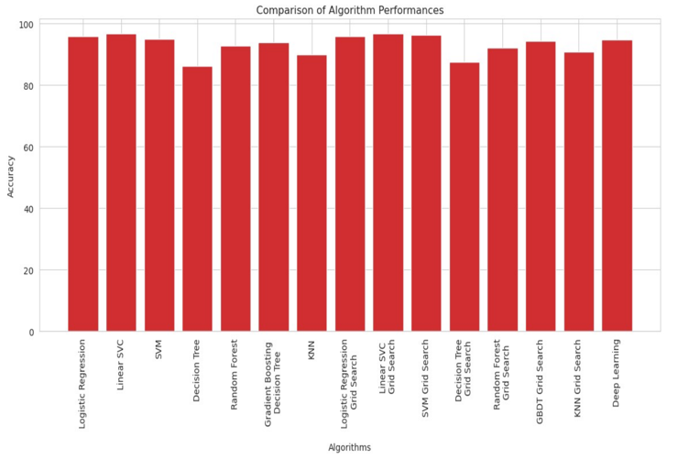

**Fig. 11: Comparison of Algorithm Performances**

**Observations (Fig. 11):**

* From the above plot, we can clearly say that the performances of Linear SVC, Linear SVC with grid search are better than the remaining algorithms.

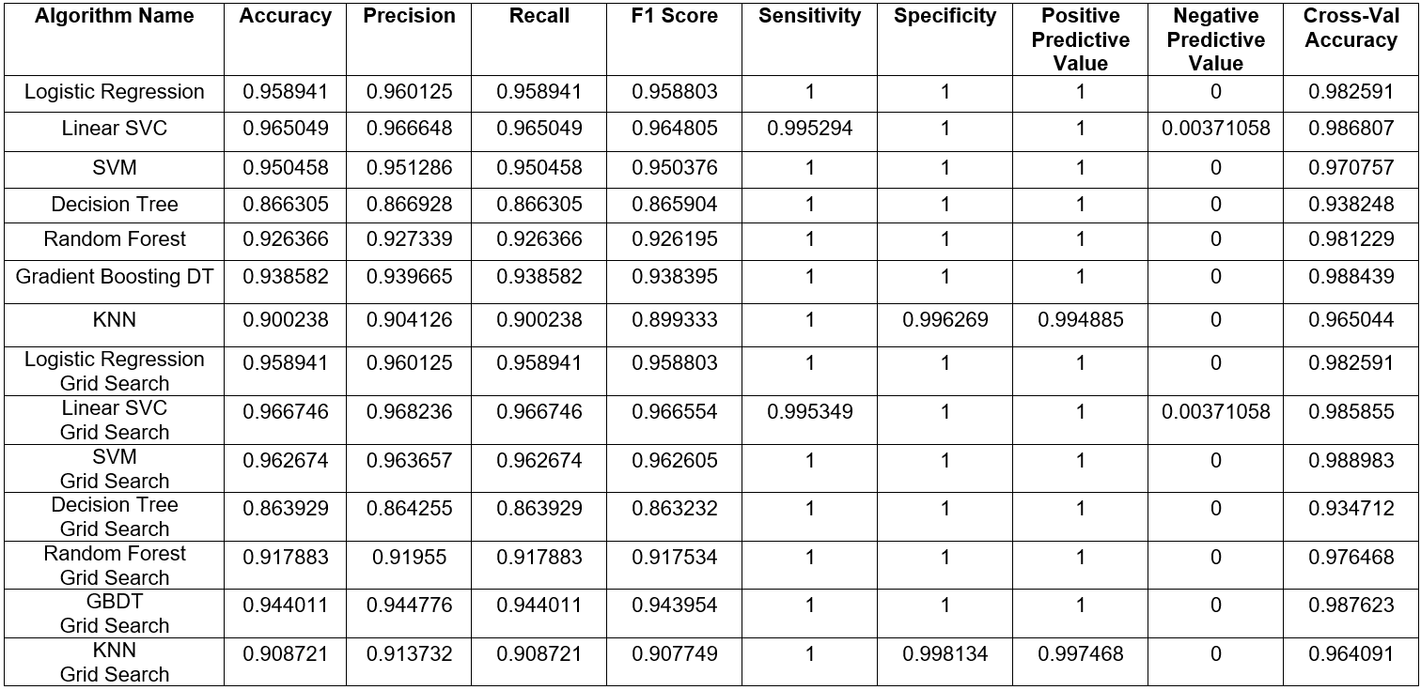

**Table 1: Comparision of Algorithm Performances**

**Observations (Table 1):**

* The results indicate that linear SVC, SVM, and gradient-boosted decision trees showed the highest accuracy among the tested algorithms. Grid search further improved the accuracy of the algorithms, especially for decision trees, SVM, and gradient-boosted decision trees.

**X. CONCLUSION**

In conclusion, this research paper has explored the effectiveness of different machine learning algorithms for human activity recognition. The study employed machine learning techniques and algorithms for training and testing purposes. Grid search was also applied to evaluate the performance of the algorithms further.

To select the optimal algorithm for Human Activity Recognition (HAR), it is necessary to consider a number of metrics, such as accuracy, recall, precision, sensitivity, F1 score, specificity, positive-predictive value (PPV), negative-predictive value (NPV), and cross-validation accuracy. Several algorithms, such as Linear SVC, Logistic Regression, SVM, Random Forest, and GBDT, perform well in terms of accuracy, recall, precision, and F1 score, as indicated by the table provided (Fig 12).

However, in order to make a decision, we must consider the aforementioned factors. The Linear SVC Grid Search algorithm has the highest precision, recall, and F1 score. Additionally, it has a high level of sensitivity and specificity, indicating that it is capable of identifying both positive and negative instances. In addition, its cross-validation accuracy is high, suggesting that the model is not overfitted.

On the basis of the presented performance metrics, we can conclude that Linear SVC Grid Search is the optimal algorithm for HAR.

The current study's results have significant implications for the advancement of more precise and effective human activity recognition systems. In recent years, the implementation of machine learning methodologies has substantially enhanced the test accuracy and efficiency of activity recognition systems. However, there are still challenges to be addressed, including the ability to accurately recognize activities in real-world environments and the integration of multiple sensors for more robust recognition. Further research is needed to address these challenges and to explore new applications for human activity recognition. Overall, human activity recognition has the potential to greatly enhance our understanding of human behavior and improve the quality of life for individuals and society as a whole.

**XI. FUTURE WORK**

* Movement and human action knowledge are proper to the AI model.
* Change this strategy to show unsurprising outcomes on a site or work area application.
* Additionally, efforts are being focused on improving the implementation of artificial intelligence.

**REFERENCES**

1. Su, X., Tong, H., & Ji, P. (2014). Smartphone Sensor-based Activity Recognition. IEEE Tsinghua Science and Technology, 19(3), 235-249.
2. Lane, N. D., Miluzzo, E., Lu, H., Peebles, D., Choudhury, T., & Campbell, A. T. (2010). A Survey of Mobile Phone Sensing. IEEE Communications Magazine, 48(9), 140-150.
3. Kose, M., Incel, O. D., & Ersoy, C. (2012). Online Human Activity Recognition on Smartphones. In Proceedings of the International Workshop on Mobile Sensing (pp. 9-14). ACM.
4. Kaghyan, S., & Sarukhanyan, H. (2012). Activity Recognition using k-Nearest Neighbor Algorithm on Smartphone with Tri-axial Accelerometer. International Journal "Information Models and Analyses", 1, 68-76.
5. Sunagawa, M., Shikii, S. I., Nakai, W., Mochizuki, M., Kusukame, K., & Kitajima, H. (2018). Comprehensive Drowsiness Level Detection Model Combining Multimodal Information. IEEE Transactions on Industrial Informatics, 14(7), 3063-3073.
6. Alkinani, M. H., Khan, W. Z., & Arshad, Q. (2019). Detecting Human Driver Inattentive and Aggressive Driving Behavior using Deep Learning: Recent Advances, Requirements, and Open Challenges. IEEE Access, 7.
7. Fahad Al-Turjman, "Human Activity Recognition Using Smartphones and Wearable Sensors: A Survey," Sensors, vol. 21, no. 5, pp. 1-25, 2021.
8. S. Banerjee and S. Mitra, "Human activity recognition: A review," in IEEE Transactions on Systems, Man, and Cybernetics: Systems, vol. 50, no. 12, pp. 1-18, Dec. 2020.
9. M. Attari, S. C. Mukhopadhyay, and H. Alhadidi, "Human activity recognition: A review on current status and future prospects," in IEEE Access, vol. 8, Sep. 2020.
10. D. Guo, L. Zhang, and D. Wang, "Human activity recognition using machine learning: A review," in Neurocomputing, vol. 374, pp. 98-116, Mar. 2020.
11. S. Hossain, A. Alamri, and M. A. Hossain, "Human activity recognition using machine learning techniques: A comprehensive review," in Multimedia Tools and Applications, vol. 79, no. 45, pp. 33927-33960, Dec. 2020.
12. S. A. M. Ali, J. A. Siddiqui, and S. S. Islam, "A comprehensive review of human activity recognition techniques," in Multimedia Tools and Applications, vol. 80, no. 16, pp. 24591-24629, Aug. 2021.
13. Y. Lu, Z. Li, and Y. Li, "Human activity recognition using wearable sensors: A review," in International Journal of Distributed Sensor Networks, vol. 16, no. 2, Feb. 2020.
14. A. Jain and P. Gupta, "A comprehensive review of human activity recognition based on multimodal data," in Journal of Ambient Intelligence and Humanized Computing, vol. 12, no. 7, pp. 5841-5861, Jul. 2021.
15. H. Pham, N. Bui, and T. Vo, "Human activity recognition using deep learning: A review," in Journal of Ambient Intelligence and Humanized Computing, vol. 12, no. 8, pp. 7445-7457, Aug. 2021.